Appendix 1. Informed consent to experts

Distinguished expert:
Cognitive Fusion is an essential element within the so-called Third Generation Therapies, more specifically in Acceptance and Commitment Therapy. The referred construct consists of mixing verbal-cognitive processes with direct experience in such a way that the individual cannot differentiate between the two.
Given the importance of Cognitive Fusion for the study of psychological inflexibility in psychotherapeutic intervention, it is necessary to have an instrument to measure this variable since there is no validated instrument for this purpose in Cuba. Therefore, the present research aims to adapt and validate the Cognitive Fusion scale from a linguistic and cultural perspective.
One of the most important aspects of the exhaustive validation is the content validity, carried out through the judgment of experts, for which the participation of specialists in the target language of the instrument (Spanish) who reside in the context is vital, since a deep analysis of the sufficiency, clarity, coherence and relevance of the items is required, as it appears in several works carried out for this purpose.
Given the competencies demonstrated by you and your background profession, we are pleased to invite you to participate as an expert or judge in this stage of the study. Your participation would be of great value as it would help in the process of implementing the reference instrument. Should you wish to participate, we guarantee the confidentiality of the information provided, which will only be used for research purposes.
The research team thanks you for your collaboration and apologizes for the time it has taken. Any doubt or suggestion aimed at improving this exercise will be taken into account. To do so, please contact Pedro García Rojas, through the phone number (+53) 5258 6105 and to the email address pgrojas8@gmail.com
Declaration of voluntariness
I have been informed about the characteristics of the study and my participation in it, so I voluntarily consent to participate in this research.

Pedro García Rojas

Judge's first and last name Investigator's first and last name

Date:

Appendix 2. Template for expert judgment

Respected Judge:
I am writing to inform you that as part of the development of the academic program of the 3rd edition of the Master's Degree in Psychological and Social Assessment, I am developing a thesis entitled: "Adaptation and validation of the Cognitive Fusion Scale for adults with anxiety symptoms". In order to give it the necessary scientific rigor, the validation and evaluation of this instrument through expert judgment is required. That is why I would like to request your participation as a judge, appealing to your academic and professional background related to the subject.
Academic background:
Areas of professional experience:
Years of work experience:
Current position:
Institution:
Research objectives: To adapt and validate the Cognitive Fusion questionnaire from a linguistic and cultural perspective, in adults with anxiety symptoms at the Mental Health Center, Cerro municipality.
Objective of the judges' criterion: To adapt the Cognitive Fusion questionnaire to the Cuban context from a linguistic and cultural perspective.
Objective of the instrument: To assess the level of linguistic and cultural perspective associated with Cognitive Fusion.
Instrument
The Cognitive Fusion Questionnaire (CFQ) is a recently published measure of cognitive fusion; a key construct in the Acceptance and Commitment Therapy model of psychopathology. The Questionnaire in its original version (CFQ; Gillanders et al., 2014). It consists of 7 items that are answered on a Likert scale with seven options (1 = Never true, 7 = Always true). The Spanish translation of the instrument will be used (Romero-Moreno et al., 2014) in its modified version by Ruiz et al. (2017), who found high alpha coefficients (between .89 and .93) in their study with Colombian population. The CFQ was intended to be used as a unidimensional measure (Gillanders et al., 2014) and several investigations provide support for this assumption (China et al., 2018; Dionne et al., 2016; Ruiz et al., 2017; Solé et al., 2016).
Brief description of the instrument.
Composition: It consists of 7 items distributed in one dimension.

Dear Contributor, in order to validate the Cognitive Fusion Questionnaire for application in Cuba, we request your participation as a Judge. Your collaboration will consist of evaluating to what extent the items or dimensions, according to the category to be evaluated, meet the criteria defined below.
According to the following indicators, please rate each of the items or dimensions, as appropriate. In case you consider a score lower than 3 and/or wish to express any suggestions, please write your considerations in the REMARKS column. The Sufficiency category is evaluated by dimensions, the rest of the categories are evaluated by items.

Attributes | Attribute measurement scale | Operational definition of the scale
SUFFICIENCY  The items belonging to the same dimension are sufficient to obtain the measurement of this dimension. | Very low | 1. The items are not sufficient to measure the dimension.
 | Low | 2. The items measure some aspect of the dimension, but do not correspond to the total dimension.
 | 3.Moderate | 3. Some items should be increased to be able to evaluate the dimension completely.
 | 4. High | 4. The items are sufficient.
CLARITY  The item is easily understood, i.e., its syntax and semantics are adequate. | Very low | 1. The item is not clear.
 | Low | 2. The item requires quite a few modifications or a very large modification in the use of the words according to their meaning or by the arrangement of the words.
 | 3.Moderate | 3. A very specific modification of some of the terms of the item is required.
 | 4. High | 4. The item is clear, has adequate semantics and syntax.
COHERENCE  The item has a logical relationship with the dimension or indicator it is measuring. | Very low | 1. The item has no logical relationship to the dimension.
 | Low | 2. The item has a tangential relationship to the dimension.
 | 3.Moderate | 3. The item has a moderate relationship with the dimension it is measuring.
 | 4. High | 4. The item is fully related to the dimension it is measuring.
RELEVANCE  The item is essential or important, i.e., it must be included. | Very low | 1. The item can be deleted without affecting the measurement of the dimension.
 | Low | 2. The item has some relevance, but another item may be including what this one measures.
 | 3.Moderate | 3. The item is relatively important.
 | 4. High | 4. The item is very relevant and should be included.

Evaluation of the items of the Cognitive Fusion Questionnaire.
ITEM | CLARITY | COHERENCE | RELEVANCE | REMARKS
1.My thoughts cause me emotional distress or pain.

2. I get so caught up in my thoughts that I am not able to do the things I most want to do.
3. I analyze situations too much, to the point that it is not useful to me.

4. I fight against my thoughts.

5. I get angry at myself for having certain thoughts.

6. I tend to get too caught up in my thoughts.

7. I find it very difficult to let bothersome thoughts go even when I know that doing so would help me.

Do you think the items are sufficient to measure the dimension?

Appendix 3. Cuban version of the Escala de Fusión Cognitiva, Cuban version (EFCvc).

Below you will find a list of statements. Please rate the degree to which each statement IS TRUE FOR YOU by circling the numbers next to it. Use the following scale to make your choice:
1 | 2 | 3 | 4 | 5 | 6 | 7
It is never true. | This is very rarely true. | This is rarely true. | Sometimes it is true. | This is often true. | This is almost always true. | It is always true.

- My thoughts cause me suffering. | 1 2 3 4 5 6 7
- I stay connected to my thoughts and am not able to do the things I most want to do. | 1 2 3 4 5 6 7
- I overanalyze situations to the point where it is not useful to me. | 1 2 3 4 5 6 7
- I fight against my thoughts. | 1 2 3 4 5 6 7
- I get upset with myself for having certain thoughts. | 1 2 3 4 5 6 7
- I tend to get very complicated in my thoughts. | 1 2 3 4 5 6 7
- I find it very difficult to let bothersome thoughts go, even when I know that doing so would help me. | 1 2 3 4 5 6 7

Appendix 4. Informed consent to the participant

Participant information:
Title of research: Adaptation and validation of the Cognitive Fusion Scale for adults with anxiety symptoms.
The objectives of this research are to adapt from a linguistic and cultural perspective the Cognitive Fusion Questionnaire, in its Spanish translation of the instrument, in patients with anxiety symptomatology who are attended in Mental Health Centers in Havana. To determine the reliability, content and construct validity of the Cognitive Fusion Questionnaire adapted for the evaluation of cognitive fusion in patients with anxiety symptoms attended in Mental Health Centers in Havana and to characterize the process of cognitive fusion in adults presenting anxiety symptoms in Mental Health Centers in Havana.
Your participation will consist of answering the questionnaires on a voluntary basis. If you agree to collaborate, you have the right to leave the study at any time you deem convenient, without any negative repercussions for you.
You may not derive any direct benefit at this time, but your participation will help us to incorporate this psychological assessment instrument for many patients with anxiety symptoms. We also inform you that the information that will be collected about you during the research will be treated with the required confidentiality, without revealing personal data that could identify you.
Declaration of voluntariness
I have been informed about the characteristics of the research and my participation in it, so I voluntarily consent to participate.

_____________________________ ______________
Participant's name and surname Signature Date: / / / 2023

Appendix 5. Charge sheet

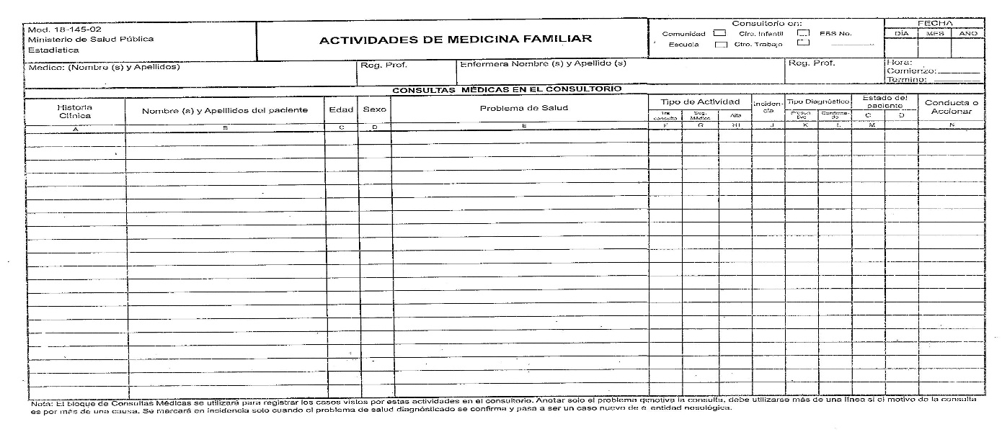
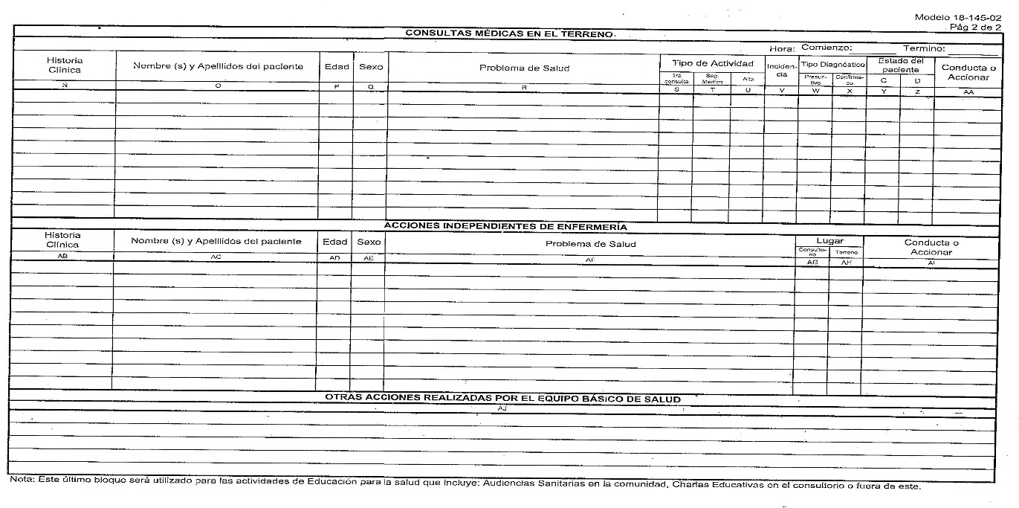

Appendix 6. Interview for the application of the Cognitive Fusion Questionnaire.

Data:
Name and Surname: Age:
Sex: Occupational status: Marital status:
APP:
Patient seen before in psychology consultation: yes__ no__
Under psychopharmacological treatment: yes__ no__.
Questions:
- In what situations do you feel their concern arises?
- How often can these sensations appear?
- What intensity do you notice in these states?
- What thoughts appear?
- What emotions appear?
- What actions do you take when this happens to you?

Appendix 7. Reliability analysis of the pilot test

Reliability Analysis
Scale Reliability Statistics
 |  | Cronbach's α
scale |  | 0.927

Element Reliability Statistics
 |  | If the element is discarded
 |  | Cronbach's α
i1 |  | 0.912
i2 |  | 0.909
i3 |  | 0.923
i4 |  | 0.918
i5 |  | 0.926
i6 |  | 0.911
i7 |  | 0.912

Appendix 8. Reliability analysis of the application

Reliability Analysis
Scale Reliability Statistics
 |  | Cronbach's alpha
scale |  | 0.869

Element Reliability Statistics
 |  | If the element is discarded
 |  | Cronbach's alpha
EFCi1 |  | 0.853
EFCi2 |  | 0.845
EFCi3 |  | 0.850
EFCi4 |  | 0.850
EFCi5 |  | 0.863
EFCi6 |  | 0.838
EFCi7 |  | 0.850

